POLITECHNIKA POZNAŃSKA – POZNAŃ UNIVERSITY OF TECHNOLOGY

Wydział Informatyki i Telekomunikacji – Faculty of Computing and Telecommunications

**Computer Aided Design**

*Project Task: Analyze a Quartz Oscillator Circuit*

AUTHOR

Wojciech Rościszewski Wojtanowski, Index No. 140062

SUPERVISOR

Dr. Eng. Sławomir Michalak

Poznań, 2021.

# **Copyright**

Copyright © Wojciech Rościszewski Wojtanowski, 2021

All rights reserved.



**_____________________**

Wojciech Rościszewski Wojtanowski

140062

# **Abstract**

For the purpose of this project we shall simulate a given circuit. The values of certain elements are given and have been chosen to best present the operation of our circuit system as well as the process of operation including temperature elements and all else. Therefore, given are suitable known analyzes as well as simulations of chosen circuit including the modifications of one model parameters.

# **Table of Contents**

**1.** **Copyright** 2

**2.** **Abstract** 3

**3.** **Table of Contents** 4

**4.** **List of Tables and Figures** 5

**5.** **Introduction** 6

**6.** **LTSPICE Simulation** 8

**7.** **MULTISIM Simulation** 17

# **List of Tables and Figures**

Figure 1 Wide-Range Oscillator Circuit Design. 6

Figure 2 LTSPICE Oscillator Circuit with Quartz Element. 8

Figure 3 LTSPICE Result of XTAL Analysis. 9

Figure 4 LTSPICE Result of XTAL Analysis Zoomed In. 9

Figure 5 LTSPICE Quartz Crystal Equivalent Circuit. 9

Figure 6 LTSPICE Measured Amplitude Response of a Quartz Crystal Equivalent Circuit. 10

Figure 7 LTSPICE Wide range oscillator with Equivalent Circuit. 10

Figure 8 LTSPICE Result from Wide range oscillator with Equivalent Circuit. 11

Figure 9 LTSPICE Temperature Sweep 10 to 100 degrees. 11

Figure 10 LTSPICE Temperature Sweep Results 11

Figure 11 New Transistor Characteristic. 12

Figure 12 New Transistor Characteristic. 12

Figure 13 WC on resistors. 13

Figure 14 Characteristic of WC on resistors. 13

Figure 15 Characteristic of WC on resistors with temperature check. 14

Figure 16 WC Analysis. 15

Figure 17 Characteristic of WC Analysis. 15

Figure 18 Characteristic of WC Analysis with temperature change. 15

Figure 19 Monte Carlo Analysis 16

Figure 20 MC Characteristic 16

Figure 21 MULTISIM equivalent circuit. 17

# **Introduction**

For the system with the following schema, design the receiving and broadcasting system by selecting the appropriate active and passive elements from the defined group of components.

For the following simulations I will simulate the given circuit in Figure 1. This is an oscillator circuit that uses two transistors, according to specification it should be operational with any 50kHz to 10MHz series resonant crystals, therefore we will design our resonant quartz crystal which will enable the operation of this circuit. Note, I will conduct in fact two projects in one where I will conduct the analysis of the behavior of our resonant quartz crystal under necessary testing methods as well as substituting the circuit into our oscillator design where we will test the effects of the same parameters.

I will now briefly conduct my visual analysis of the circuit and expand on the wiring demonstrated of the Figure 1. We see firstly the Q2 resistor, here we see an emitter follower design else known common collector amplifier it is a basic BJT amplifier. In this particular combination we see that from Q2 emitter leg is the output signal that is being lead back towards the input of the Q1 emitter, see the wire with the capacitor (C2) and we see that this signal also quite clearly travels into our (XTAL) Quarts crystal series-resonant crystal element. We then see that the Q1 transistor is then wired in such manner that the circuit from that loop has a common base – therefore, we can say that this is a common base amplifier.

To Conclude: we have a common base amplifier, an common collector / emitter follower and a resonant quartzcrystal design.

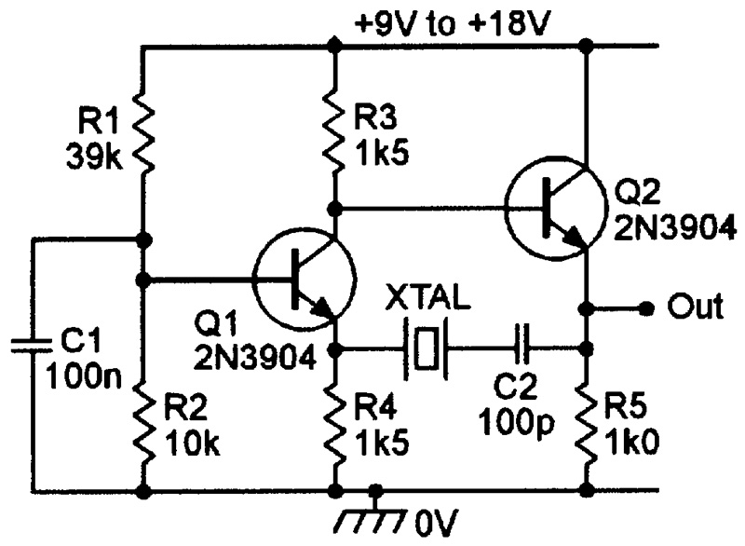

Figure 1 Wide-Range Oscillator Circuit Design.

Therefore, knowing all of these necessary combinations of details we are able to connect the dots and perform our calculations. Not exactly, because we firstly need to describe our parameters. To have some consistency throughout this project a equivalent circuit of the quartz crystal will be made, these please see the drawing below presenting the mentioned equivalent circuit that will be used throughout this entire project in our wide-range oscillator circuit design.

As it can be quite clearly noticed in the drawing (figure 2), we see that the “quartz crystal” will have a series resonance (see, Cs and Ls) as well as our parallel resonance. We will later perform a frequency sweep (AC Analysis) in order to see how our circuit really works and how in more advance it performs, therefore we will be able to test-fix if our calculations have been correct. But firstly, we need to know the values of R, Cs, Ls and Cp. Please note that one calculation for all won’t be enough.

In the below please see in detail the variables used as well as their descriptions:

* Cp – Holder Capacitance,
* Fs – Series Resonance Frequency,
* Fp- Parallel Resonance Frequency,
* R – dynamic losses.

I would like to achieve a 4MHz resonating crystal element, therefore for this case I will select fs to be 4MHz.

# **LTSPICE Simulation**

For the purpose of this project we will use necessary tools in this case our LTSPICE environment in order to perform our simulation. The goal here is to generate as much sufficient data from the program to see deeper into our phenomenon, in this case with the use of the LTSPICE system it is possible to set different parameters and experiment with our circuit design.

To begin conduction analysis of my parameters I firstly remake the entire circuit in LTSPICE environment, as seen in the figure below I have designed an almost identical system as presented in our original circuit (Figure 1 for reference). Please notice that this is not exactly our circuit since we are using a predefined symbol of our XTAL quartz resonating crystal. I have made the following circuit only in attempts to see how the system should behave ideally. Parameters used to conduct this circuit can be found in the below. I have also found that this circuit is quite limited as it can only operate between ideally the ranges of 50kHz and 10MHz, however this will be discussed later.

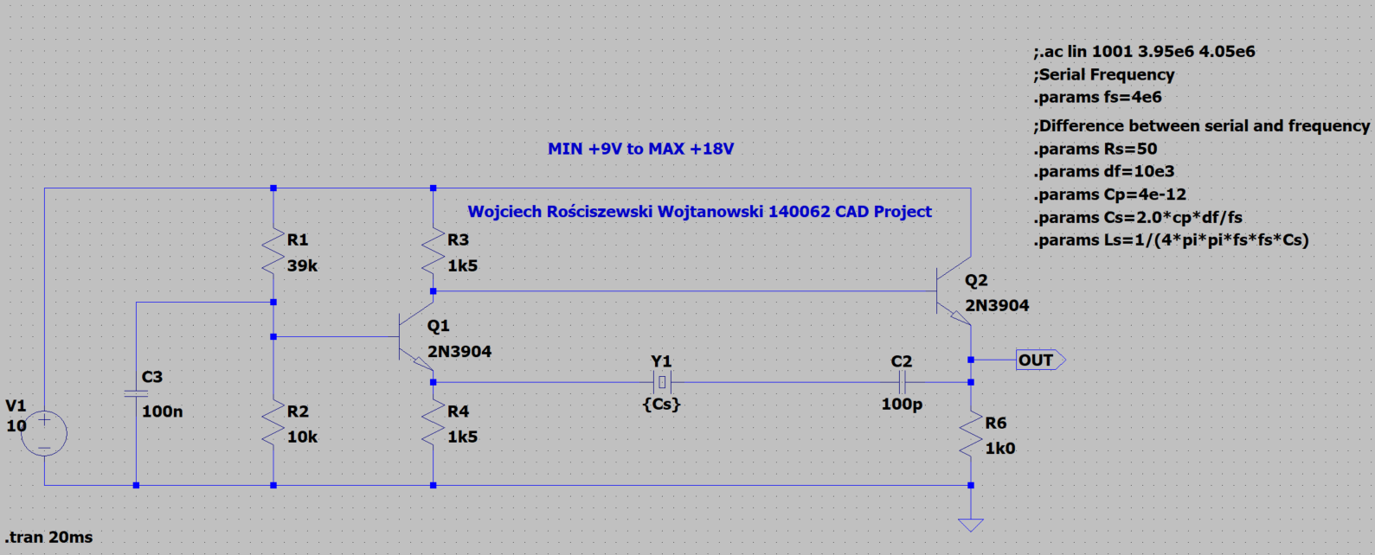

Figure 2 LTSPICE Oscillator Circuit with Quartz Element.

As seen the circuit has been constructed. Below I have included the following formulas which enabled me to calculate the ideal parameters that I will need for my quartz crystal to operate. I have had many tries at this I must say, however I think I’ve found that the higher the value results in poorer results whereas too little isn’t very sufficient so it was quite a challenge to find some ideal “in between” values that can be sufficient enough for this simulation to be demonstrated as accurately as possible. Please refer to the calculations from the introduction stage of this project.

In the figure below please see a graph presenting the output waveform of the entire system, this analysis has been conducted in the time domain and we see that the oscillator is oscillating between 9.3V to 3V.

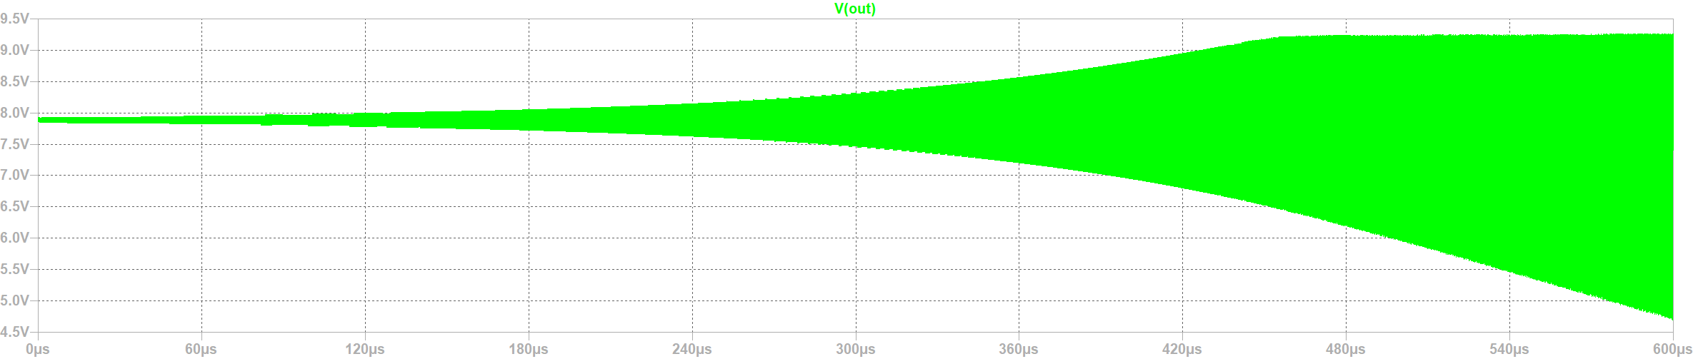

Figure 3 LTSPICE Result of XTAL Analysis.

In the figure below please see the output waveform just zoomed in. We see that the sinusoidal signal is generated successfully (note that no other sources except from a DC voltage has been inserted into the simulation).

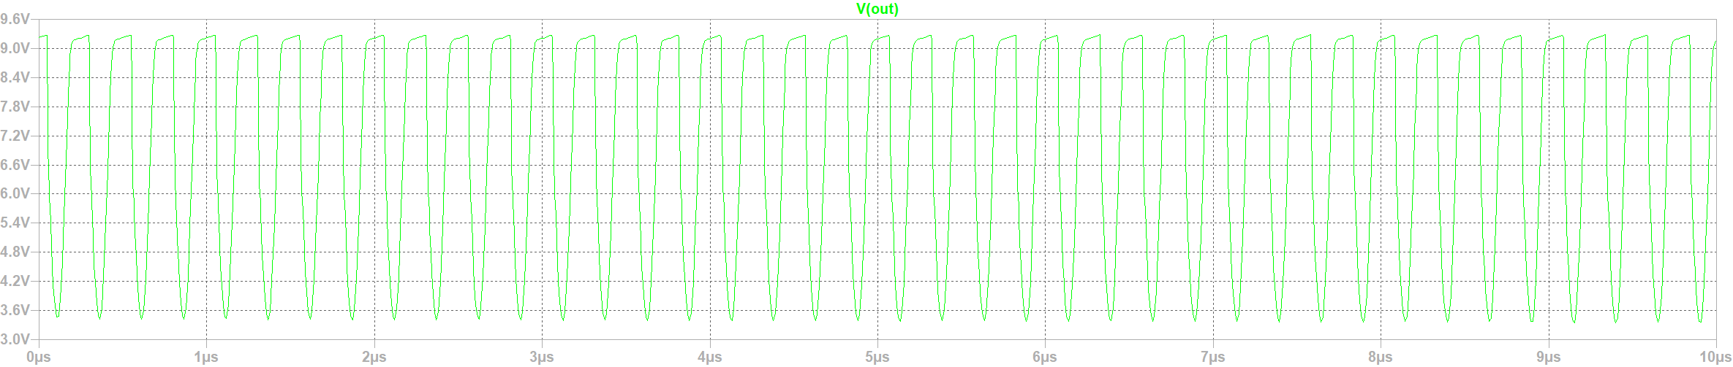

Figure 4 LTSPICE Result of XTAL Analysis Zoomed In.

In the figure below please see my design of the equivalent circuit from the introduction sections, however with significant modifications so that it is operational within out simulation environment. I have performed frequency analysis (AC Analysis) in order to present the characteristic of the operation of our designed quartz crystal equivalent circuit.

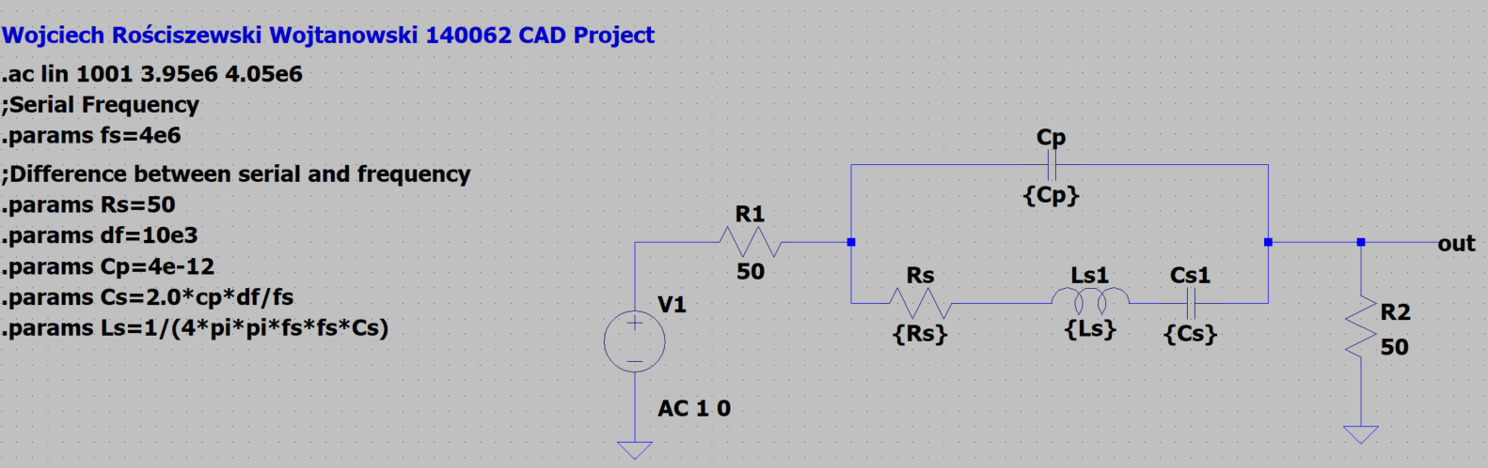

Figure 5 LTSPICE Quartz Crystal Equivalent Circuit.

In the figure below please see the output waveform of our signal, this is the frequency analysis as mentioned in the point above. To add some overall description this is our series / parallel resonance frequency of our resonating oscillator circuit. So how does this phenomenon occur? Well the first peak (going up) is the series resonance of our frequency as this is the connection between the voltage source (here we have 1V of alternating current AC) and the load. So the maximum amplitude is our first peak, this is our fs (so Ls = Cs). The minimum amplitude (second peak doing down) is our fp (so for Ls, Cs, Cp). In short, this is our fundamental mode. All other frequencies that are generated in the example above and quite possibly in our application in the main circuit we should see some spurious frequencies that might affect how the waveform looks like however should be minimal since our amplifier is tuned between a range of parameters, this will be overviewed later.

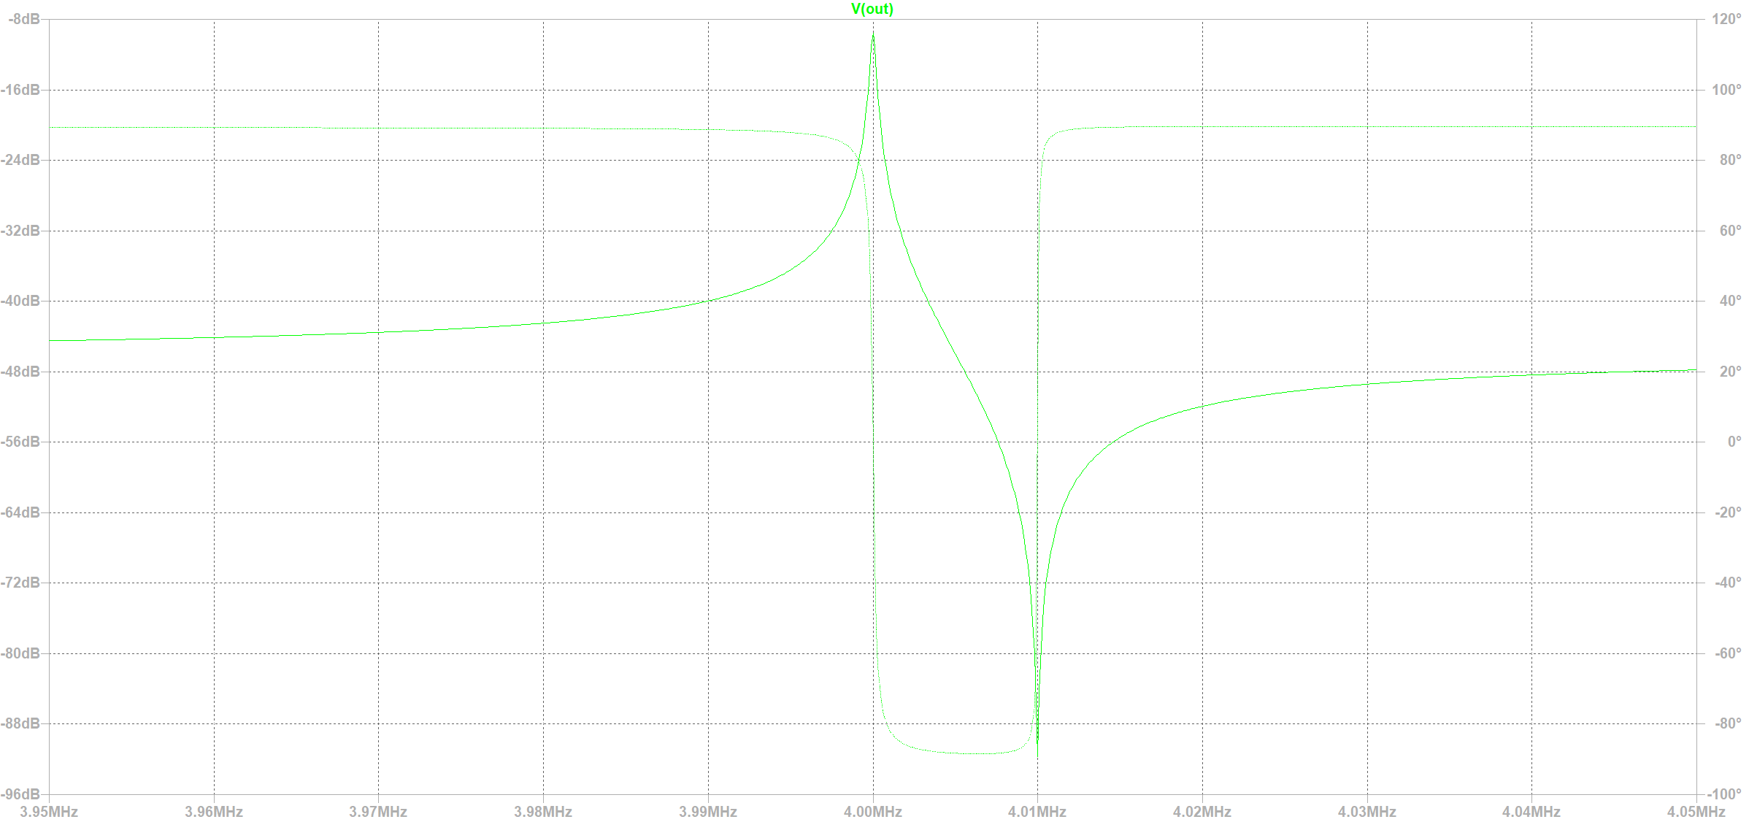

Figure 6 LTSPICE Measured Amplitude Response of a Quartz Crystal Equivalent Circuit.

In the below please see our wide range oscillator circuit but with the minor difference with the insertion of our equivalent circuit. There is nothing much to describe, we know the minimal and maximal values therefore I apply here the voltage of 10V to fit within the range, I don’t really want to go over the top since the number of oscillations are dependent on this.

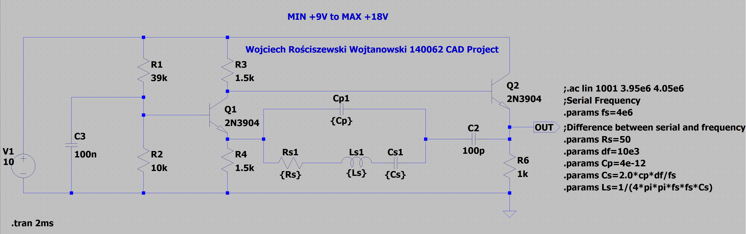

Figure 7 LTSPICE Wide range oscillator with Equivalent Circuit.

In the below please see our output waveform, our results seem to be correct as the values are limited between 9.3V to 3.0V therefore this is ideally the same as the first assumption of our circuit hence why we can say that this circuit has been redesigned successfully. From this we can now carry on and perform various parameter changes and asses the performance of our circuit.



Figure 8 LTSPICE Result from Wide range oscillator with Equivalent Circuit.

For the next part I have performed temperature analysis sweep (from 10 to 100 degrees, 10 increment), this is to show how the entire circuit is affected under temperature changes and how vital it that we do not power certain circuits under various temperatures since they can be damaged. For example old radios used old carbon resistors, diodes, transistors which need to reach their optimal temperature before use since these components can be damaged.

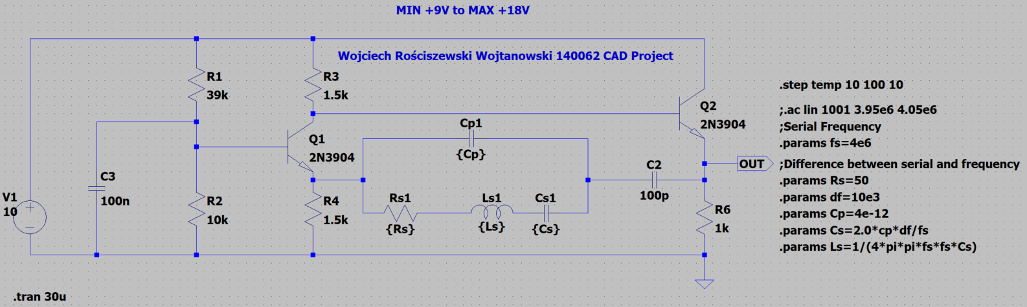

Figure 9 LTSPICE Temperature Sweep 10 to 100 degrees.

In the below please see the output characteristic of our temperature sweep, what do we see? We see exactly what we have predicted, the circuit changes the output characteristic and therefore temperature is a vital parameter of our circuit. We will analyze our circuit transistors more in depth later.

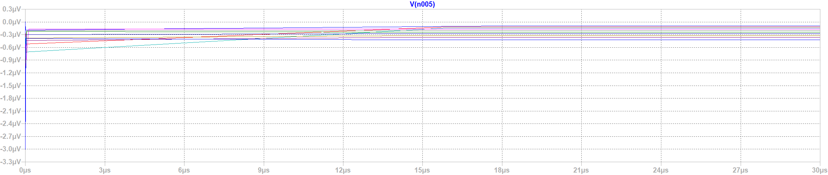

Figure 10 LTSPICE Temperature Sweep Results

In conclusion we see that the lower the temperature we see that it slowly achieves the values, but this is correct since in all circuit we take 27 degrees as the normal operating temperature. Therefore, the beginning values are in fact closer to our expectation yes, whilst the higher values are the overshoot. We see in the plot that anything at and past 40 degrees our circuit shoots straight up and instantly is operational, this is bad we do not want this since the parameters should be achieved gradually.

From this point we will focus on the performance of our transistor Q2. We will perform various analysis, so temperature effects, monte carlo simulations, worst case simulations. However, we must firstly choose a different amplifier, why? If we look closely at the waves our amplifier overshoots, this can be seen in the figure presenting the output characteristic of our circuit, we see that the sinusoidal waveform is simply cut off therefore we must select an amplifier with a lower gain value since our system quite literally cannot handle this amount of gain.

For this case I have selected the 2SCR375P transistor. Please see the following characteristic of our system. What do we see? A perfect sinusoidal waveform that indeed isn’t overshot. Below see also the circuit with new transistors.

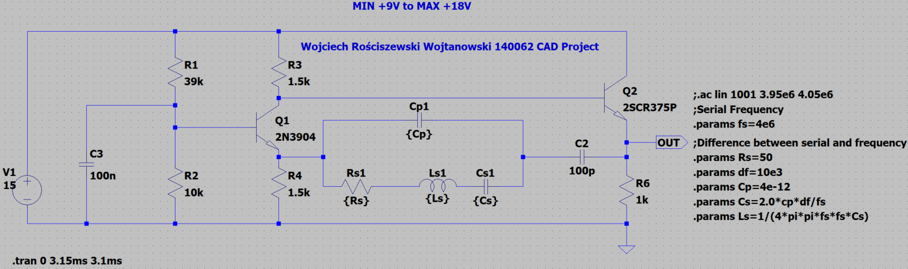

Figure 11 New Transistor Characteristic.

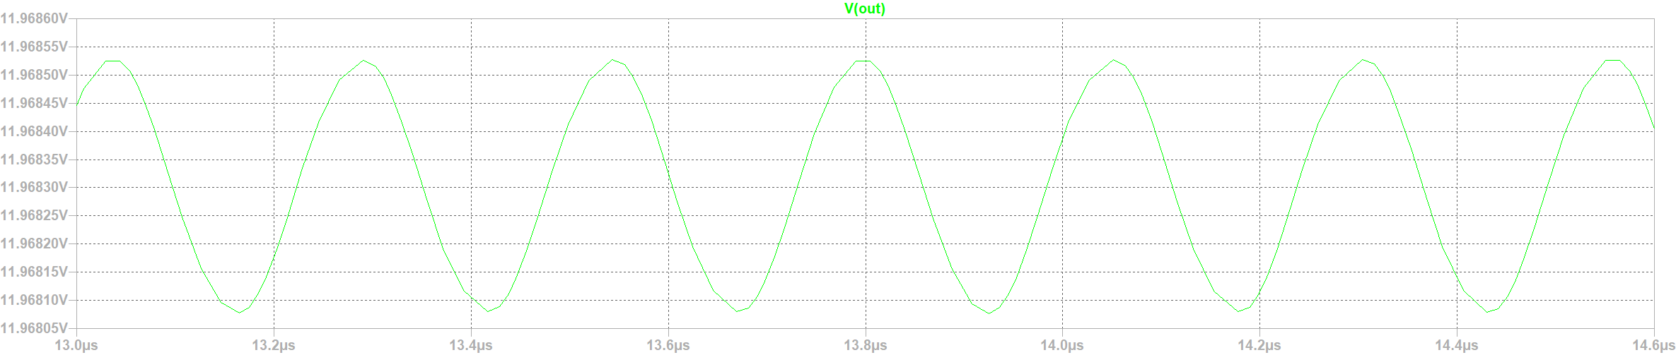

Figure 12 New Transistor Characteristic.

For this next step we will perform the worst-case simulation. Just for sake of demonstration I have done this for the resistors. To show how the system is affected in general. We will perform the same on the transistor Q2.

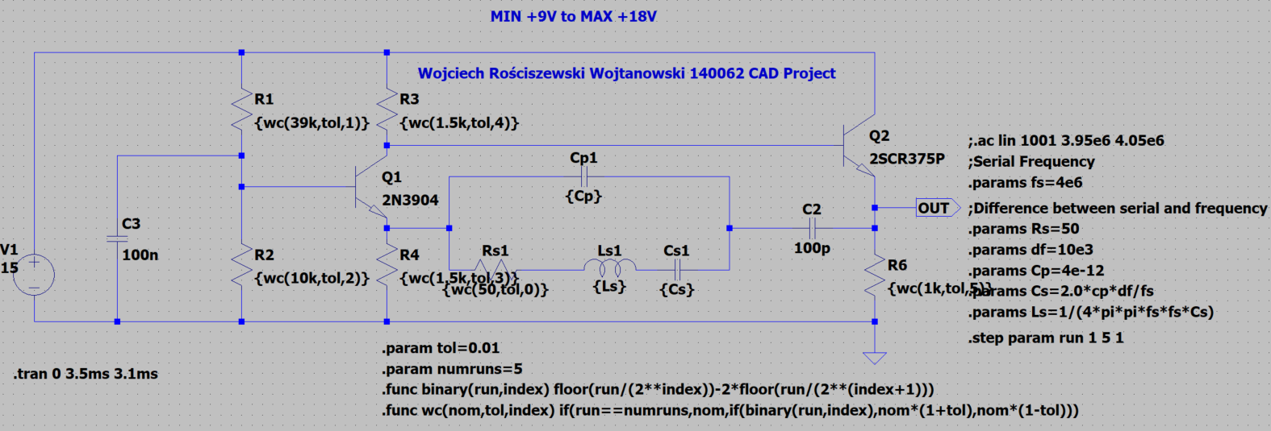

Figure 13 WC on resistors.

As we can see the values change a lot for the tolerance of the resistors, we have successfully generated the minimal and maximal voltage values of our circuit. We will attempt to do something similar for our transistor.

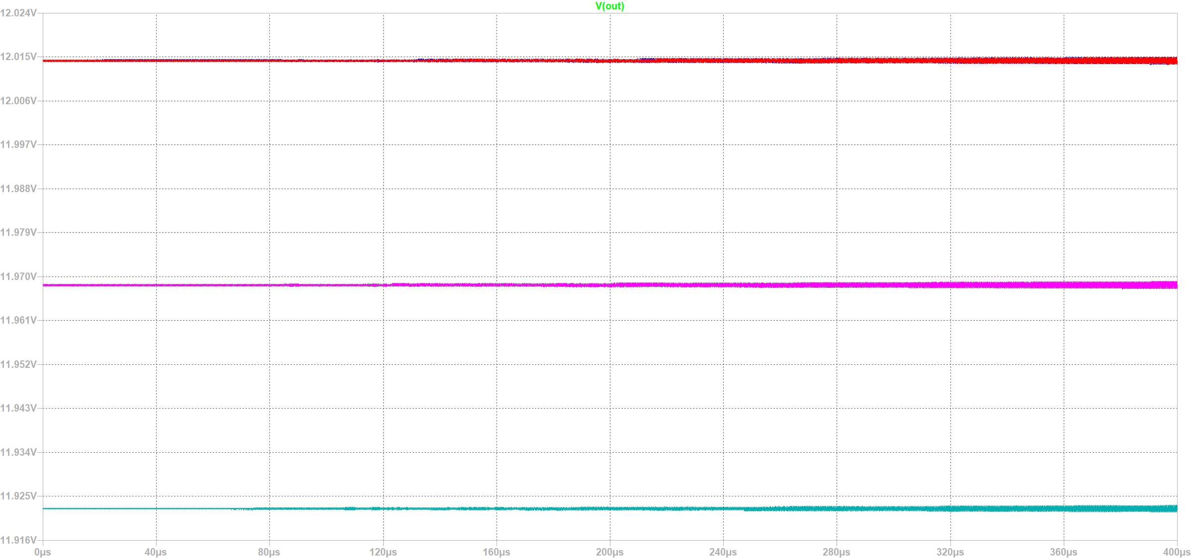

Figure 14 Characteristic of WC on resistors.

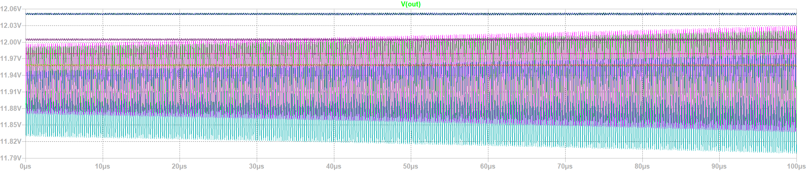

Figure 15 Characteristic of WC on resistors with temperature check.

(Before Bf=153)

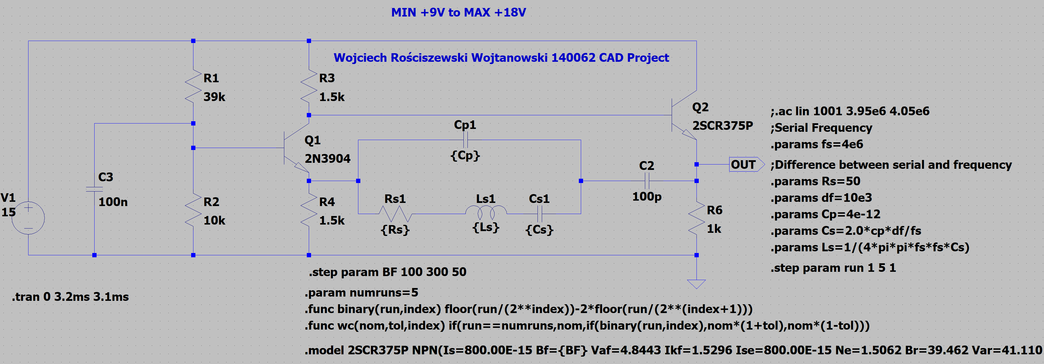

Figure 16 WC Analysis.

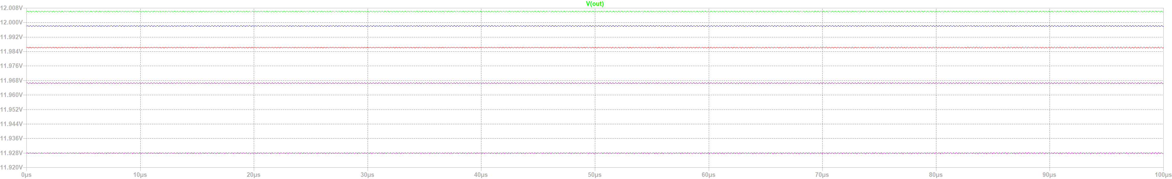

Figure 17 Characteristic of WC Analysis.

Wc with temp effects

10 – 100 degrees.

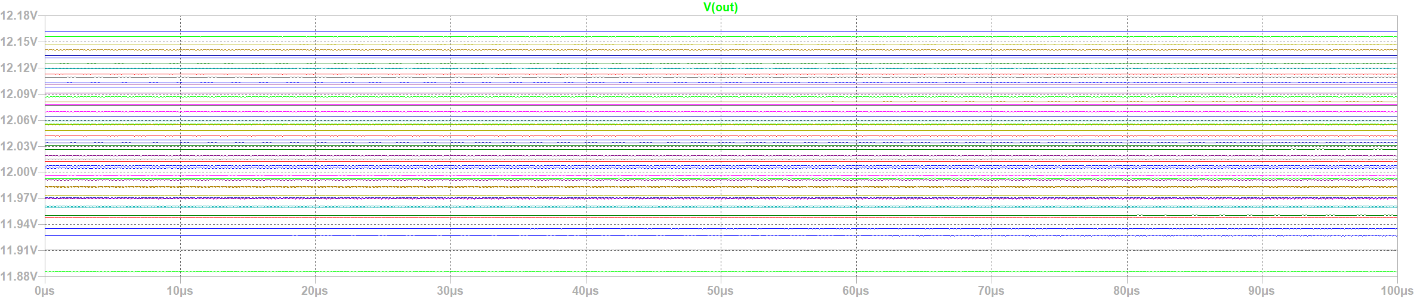

Figure 18 Characteristic of WC Analysis with temperature change.

Mc

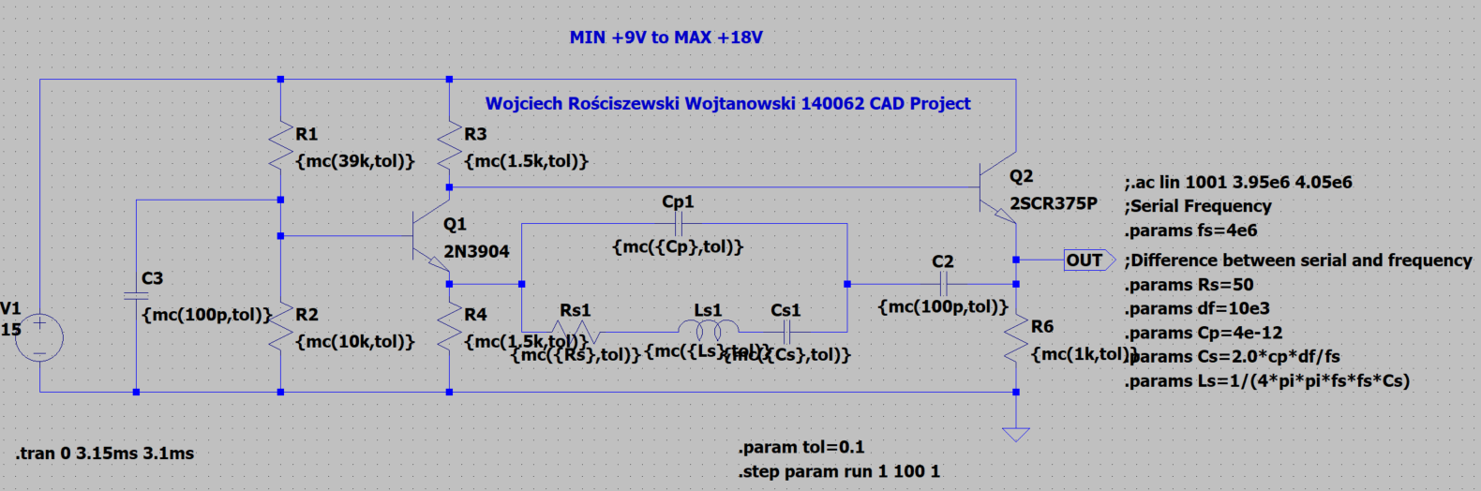

Figure 19 Monte Carlo Analysis

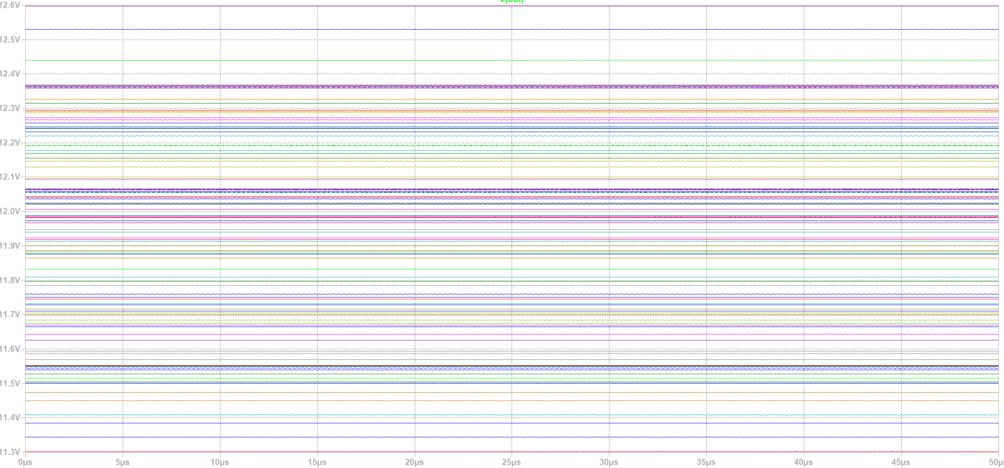

Figure 20 MC Characteristic

Conclusion:

# **MULTISIM Simulation**

For this part of the project we’ll conduct similar test just as in LTSPICE program above. We will analyze the same circuit system of our wide-band oscillator circuit.

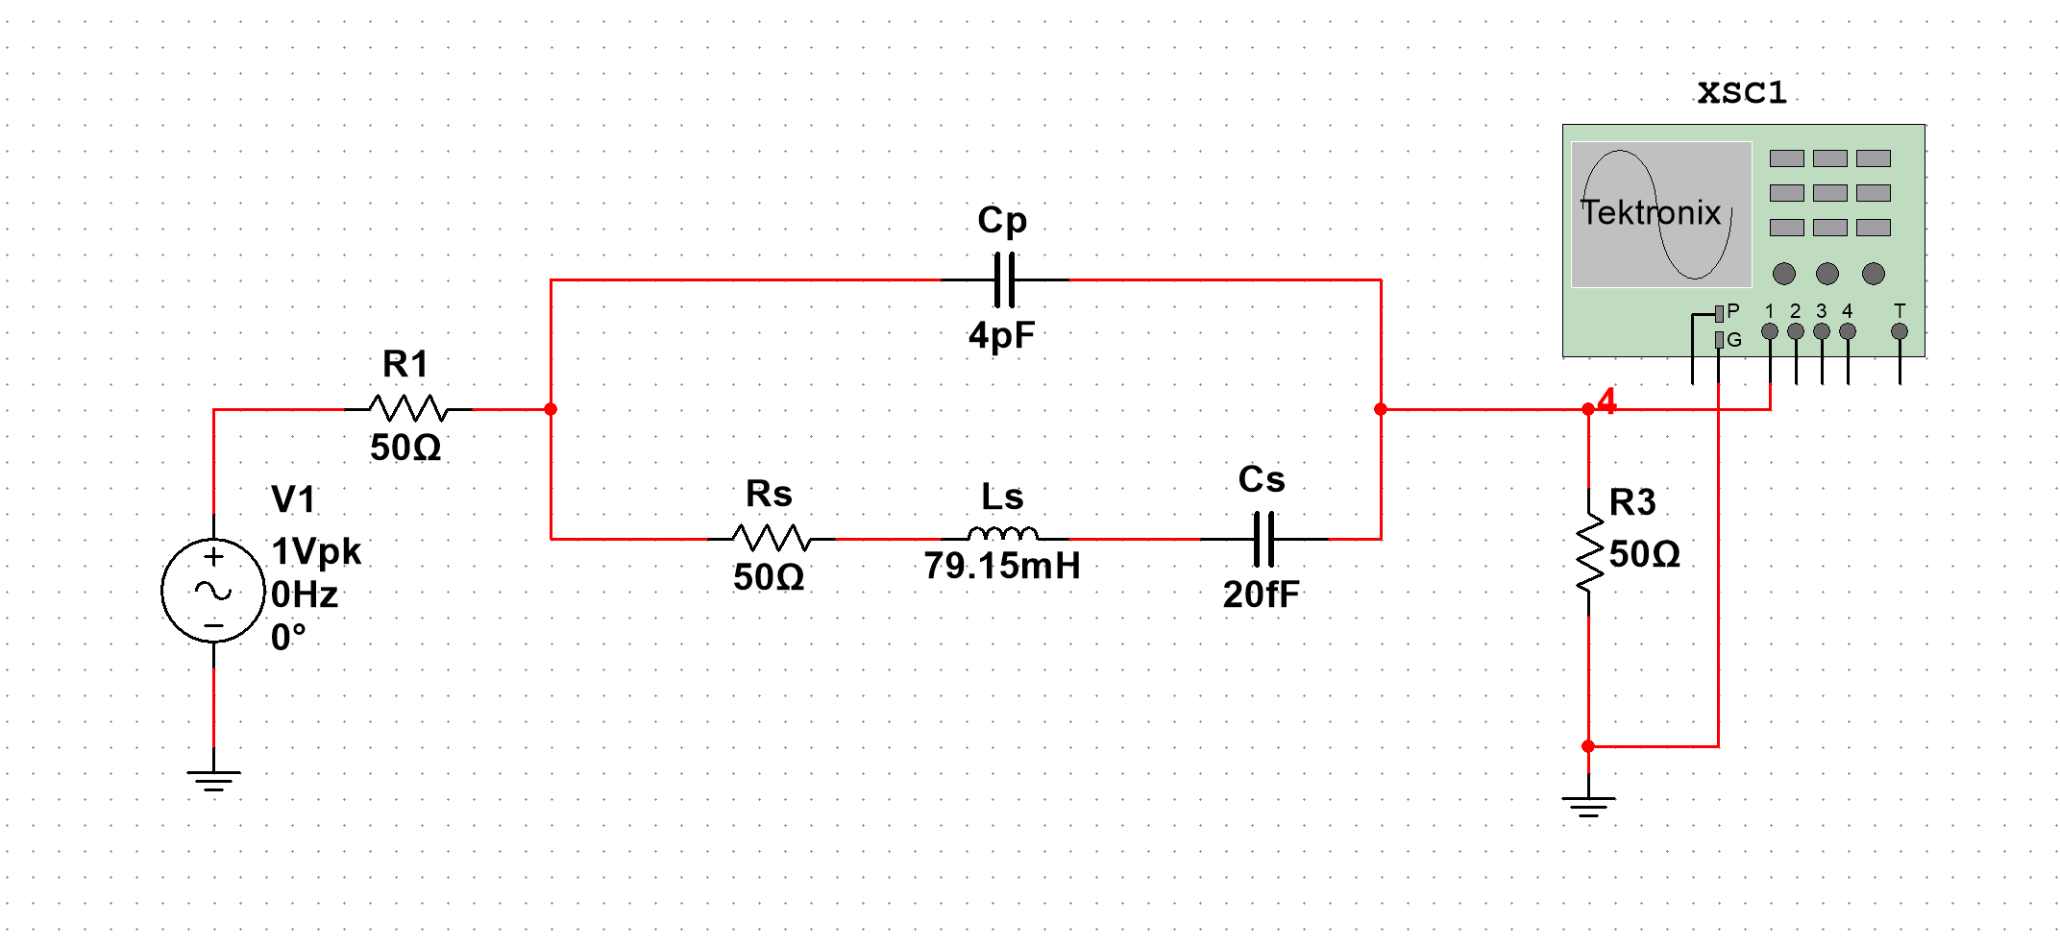

Figure 21 MULTISIM equivalent circuit.

In the below please see the results of (todo)